To Die Dreaming is a popular drink of that Dominican Republic. This is usually made with orange juice, evaporated or regular milk, sugar to taste and ice cubes. Sometimes, vanilla is added as well. The recipe for the “To Die Dreaming” beverage varies greatly depending on regions or according to one’s personal taste. The drink has the most poetic name of all Dominican beverages. The name of this drink is given in honor of those that died while dreaming our freedom or independence.

We need to principal steps done before to get started the making of “To Die Dreaming.” These are the tools and ingredients that we are going to use during the preparation.

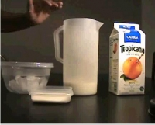
First step, make sure that you have all the right tools before beginning. These tools include a pitcher, spatula, measuring cup, can opener and a mixer (optional).

Second step, you must have the principal ingredients, such as evaporated or regular milk, orange juice, sugar, vanilla extract (optional), and ice cubes.

You can begin the making of To Die Dreaming once you have the ingredients and tools mentioned above. Now that you are all set, calculate the amount of people that is going to drink in order to know the amount of ingredients. In case of four people you need to have the following ingredients:

- Two cups of orange juice
- Half cup of sugar
- Four cups of evaporated milk
- Two in a half cups of ice cubes

Once we have these ingredients we proceed to the preparation steps. This is a simple and quick process that takes approximately 10 minutes.

First, use a pitcher to place the milk. Then, begin mixing the sugar with the milk until it has dissolved.
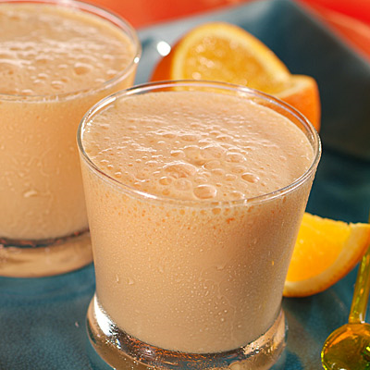
Second, this is the part where you must be careful because the ice must be added to the milk and not the orange juice to be able to pour both ingredients. After this, pour the orange juice slowly into the milk and stir constantly.

Third, once you have ended, serve immediately to savor its delightful taste.

This is a fantastic and tropical drink from the Dominican Republic. It is so famous because of its wonderful flavor and its simple ingredients. To Die Dreaming is the result of a good combination of ingredients such as orange juice, evaporated or regular milk and sugar in an appropriate way.

